CENWP-OD-B 8 December 2014

MEMORANDUM FOR THE RECORD

SUBJECT: 14BON81 MFR BI bridge overlay follow on work

Description of the problem-
On 8 December, Small Projects contacted NWP Fisheries to discuss the need for some work on the BI Bridge. The BI Bridge overlay (MOC 14BON08) has a few follow-on items that the contractor and Small Projects would like to complete as soon as possible.

There is a section on the west approach, about 40 feet west of the fish ladder, encompassing about a 20 ft x 15 ft section that has footprints. Additionally, there is a 3 ft x 9 ft section on the bridge deck itself that is a low spot that will be addressed in order for the water to drain off that portion. In these two sections, the Contractor has proposed to remove the top 2 inches of concrete and overlay the concrete with the same concrete mix as was placed on the bridge deck.

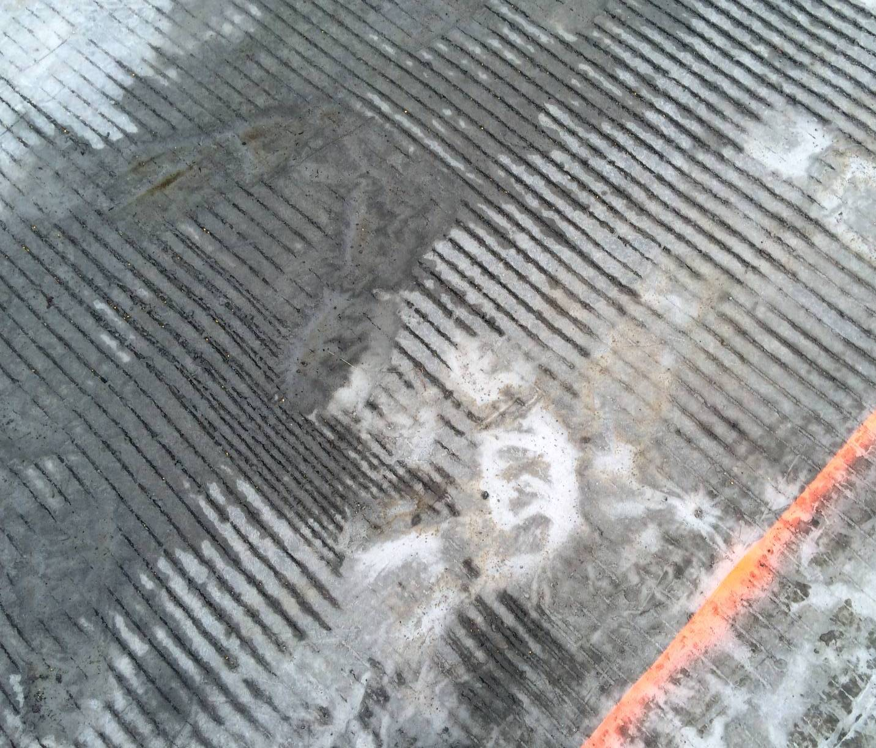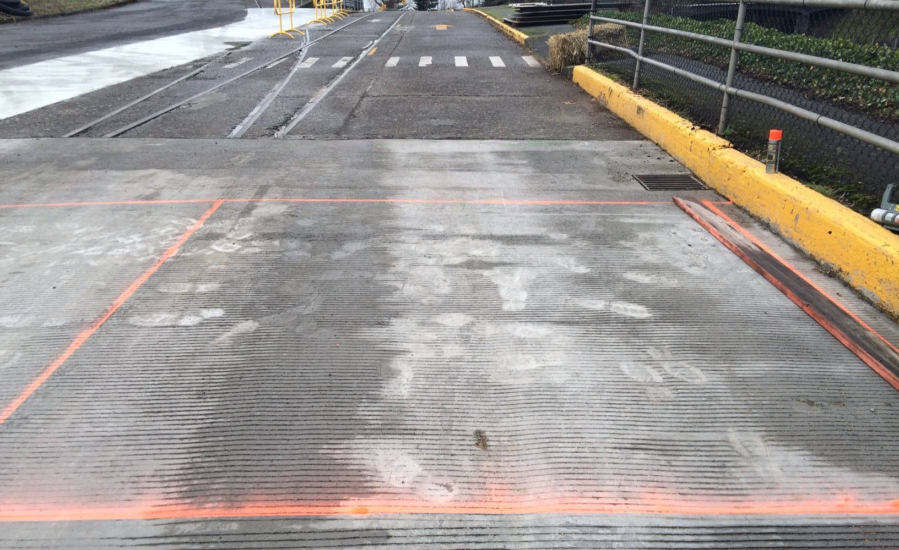
Picture 1. Footprints in the concrete. Picture 2. Westbound lane repair area. The drain is located 50’ from the fishway.
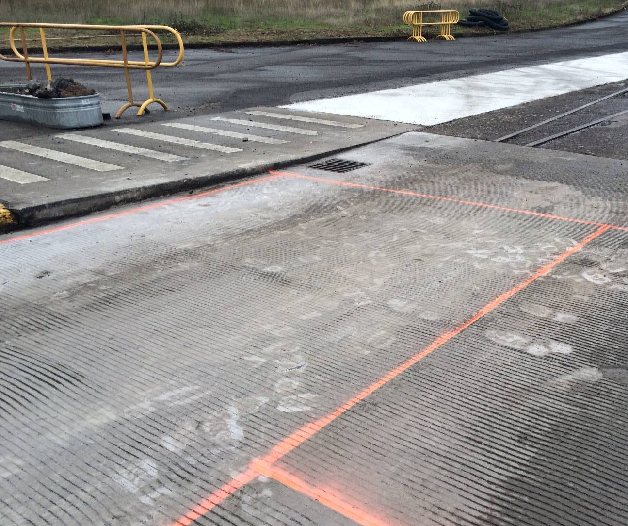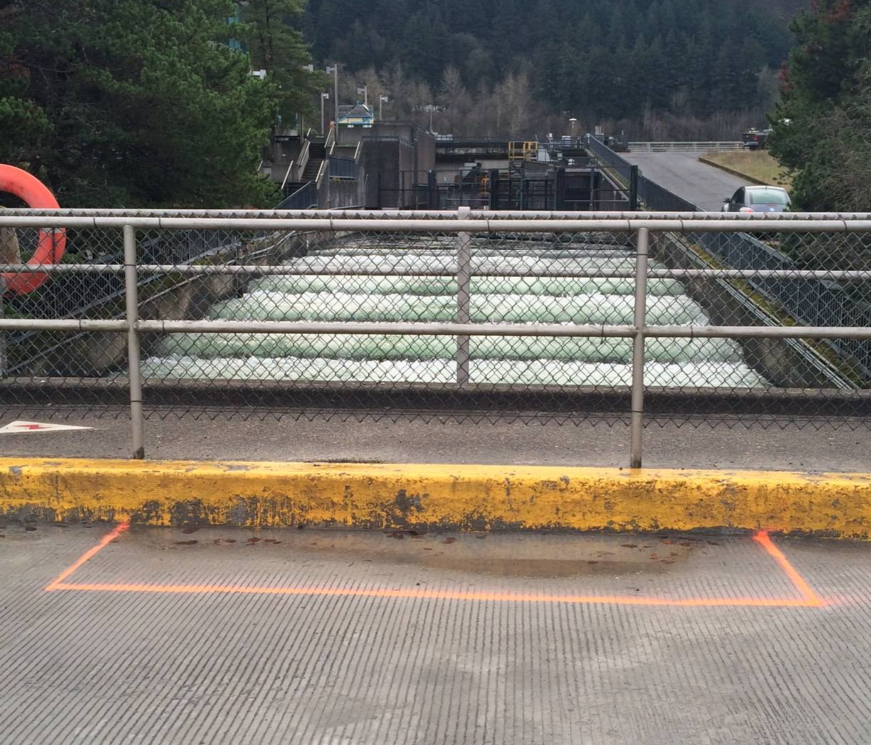
Picture 3. Eastbound lane repair area. Picture 4. Low spot in the center of the
The drain is located 50’ from the fishway. bridge.

The method proposed to achieve this solution is to saw cut the 2 inches below the surface around the perimeters of the affected areas. Additional saw cuts will be made to create a grid. The pieces of concrete will be hand chipped with a 15 lb mechanical hammer. If hand chipping does not produce the desired profile, a grinder will be brought in to create an even surface. The grinder is about 3 feet wide and produces minimal noise and vibration.

On the bridge deck, while the section is being addressed, boards will be erected in order to prevent any debris going into the fish ladder. The concrete that will be chipped will be contained and hauled offsite.

Saw cutting the area into 2” wide sections was completed on 8 December. Chipping will occur on 9 December. The first pour may occur as early as Wednesday, 10 December and the second pour will occur by 15 December. All concrete should be cured and the area returned to normal by 19 December.

Dates of impacts/repairs –
8 December – saw cutting the affected area into 2” wide sections.
9 December – chipping out the concrete and hauling it off-site.
10 December – first concrete pour.
NLT 15 December – second concrete pour.
19 December – area is clean and contractor is off-site.

Expected impacts on fish passage – This work is being completed during the normal winter maintenance period. Bradford Island fishway is the only operating fishway at BON right now. These repairs to the BI Bridge are within the 50’ buffer, however, there are less than 100 salmonids passing through Bradford Island each day. This work is not within 50’ of a downstream passage facility and is it not occurring during the normal lamprey migration season.

Date | All Chinook | All Steelhead | Clipped Steelhead | Unclipped Steelhead | All Coho
12/1/2014 | 0 | 24 | 9 | 15 | 13
12/2/2014 | 3 | 30 | 13 | 17 | 23
12/3/2014 | 2 | 21 | 11 | 10 | 13
12/4/2014 | 2 | 35 | 21 | 14 | 5
12/5/2014 | 4 | 24 | 10 | 14 | 5
12/6/2014 | 7 | 38 | 20 | 18 | 19
12/7/2014 | 1 | 32 | 16 | 16 | 14
12/8/2014 | 6 | 41 | 23 | 18 | 23

One note of interest – when the original overlay work was completed, the contractor repaired the roadway out to 55’ from the fishway. This will help reduce conflicts with the fishway and road repair work in future years.

Comments from Agencies – (new section to be added to all MFRs if the FPP change form gets approved in January)
NOAA Fisheries – (Fredricks via phone call) – this work should be ok since it is winter maintenance and is short in duration for vibration/noise activity. He did repeat his desire to have discussion about MFRs rather than the document be final once it is sent out. In anticipation of that, this MFR will be on the December FPOM agenda for further discussion.

CRITFC – (Lorz via phone call) – concerned about work occurring at BI when it is the only ladder in FPP criteria.

Sincerely,
NWP Fish Section and Small Projects
BON Project Tech Staff

